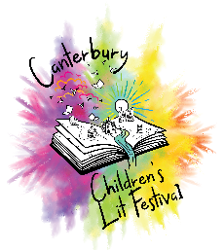
Readathon Sponsorship Form
We are raising money for the 2026 Canterbury Children’s Literature Festival, to help bring amazing authors, illustrators and storytellers into local schools. Please sponsor me per page or per book read!
Name | Amount Per Page | Amount Per Book | Paid
www.canterburykidslitfest.co.uk

